Logo here?

The Preparator©



User Guide

Using the System (Lecturer)

1. Log into Moodle with your credentials

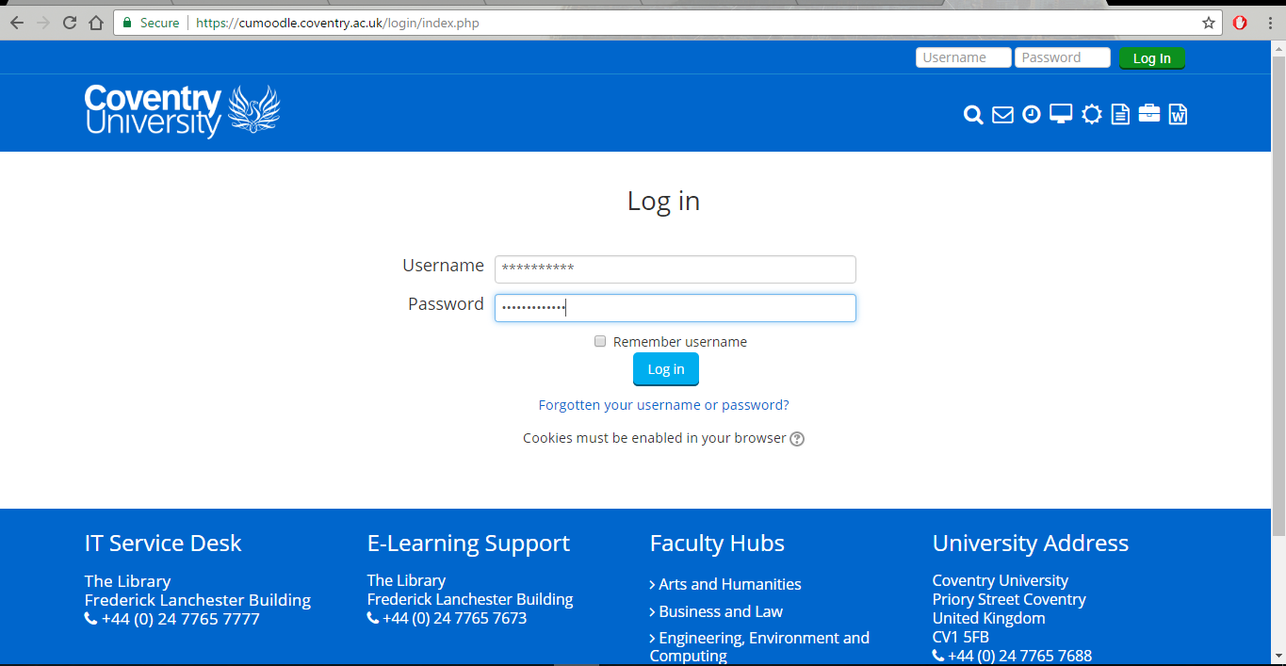

1. Select a module

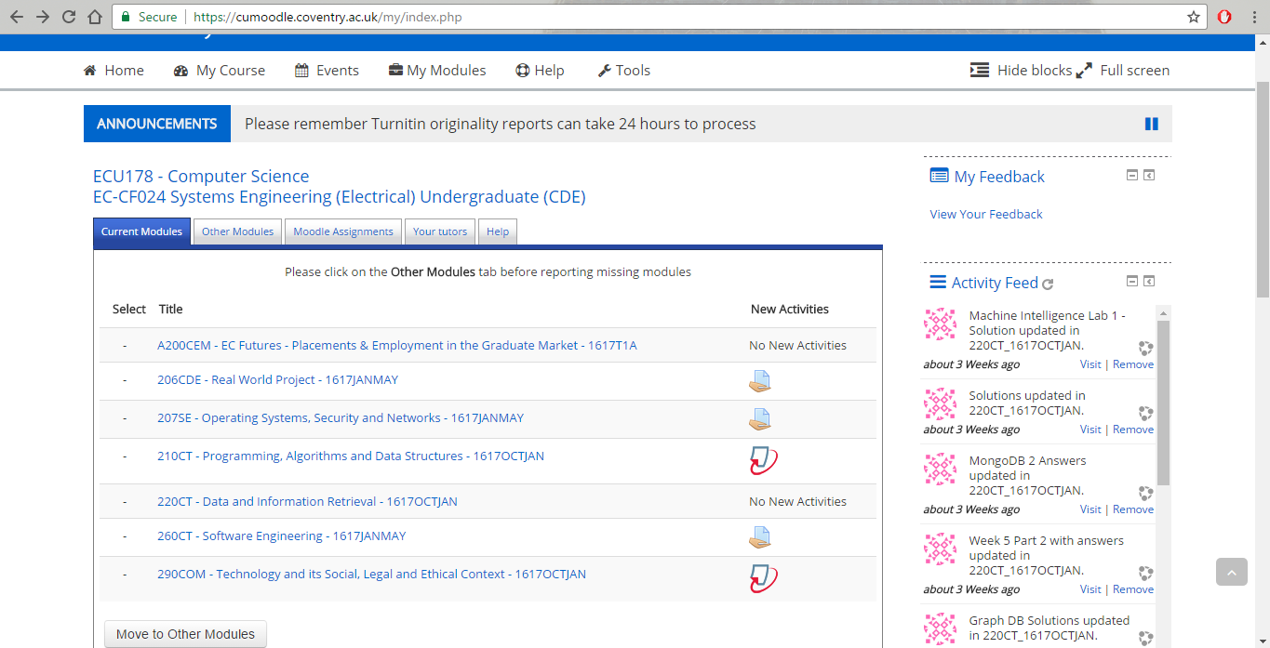

1. Select extension called ‘The Preparator’.

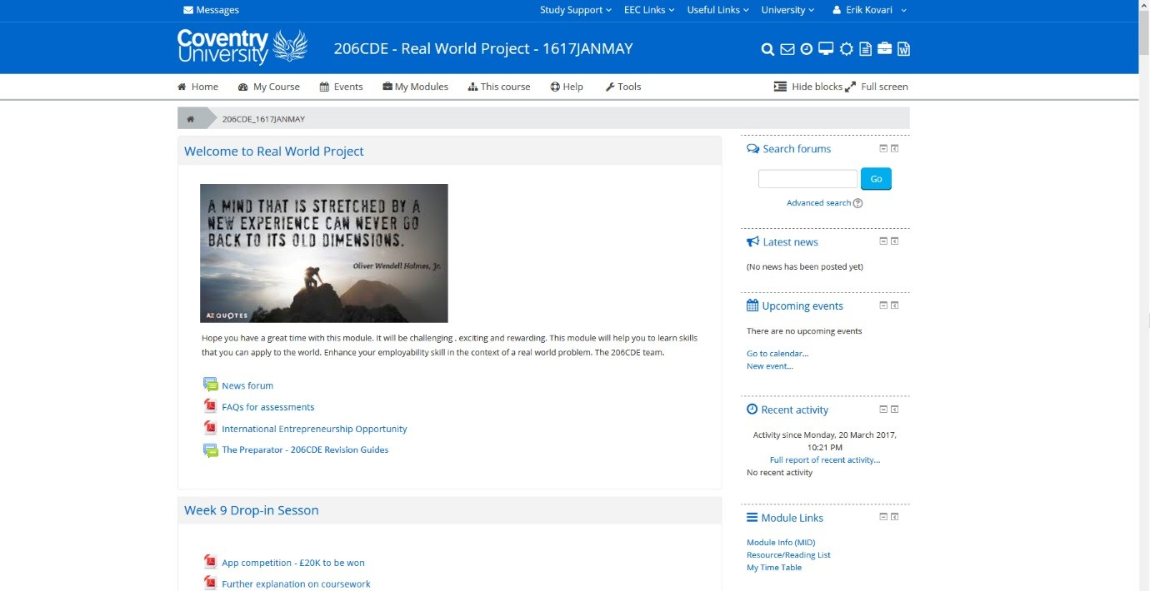

1. The Preparator window opens

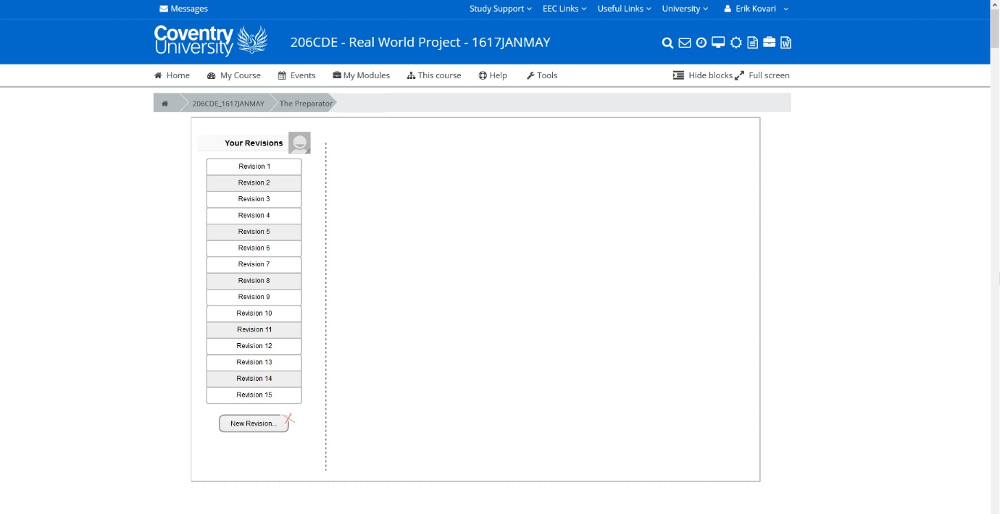

1. Click new revision and add new files/parts of a file to the timeline

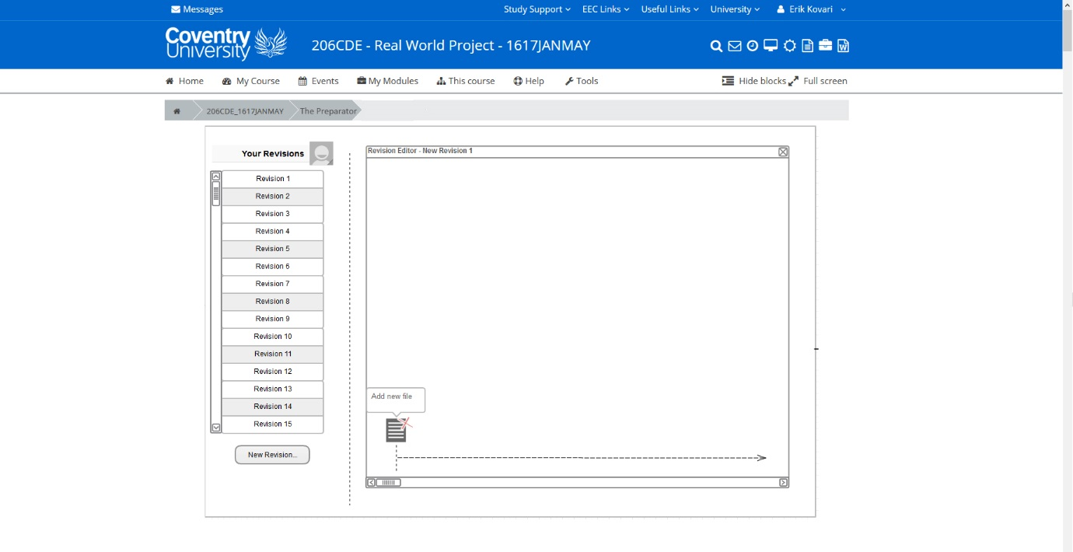

1. Browse the Moodle directory and select the one you want

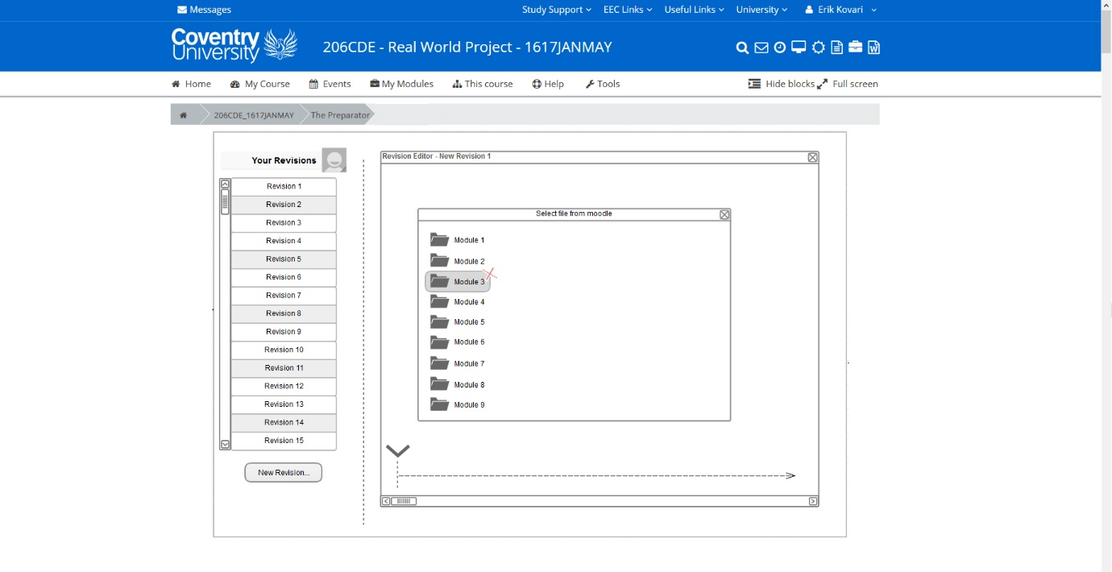

1. Select the document to put the information in.

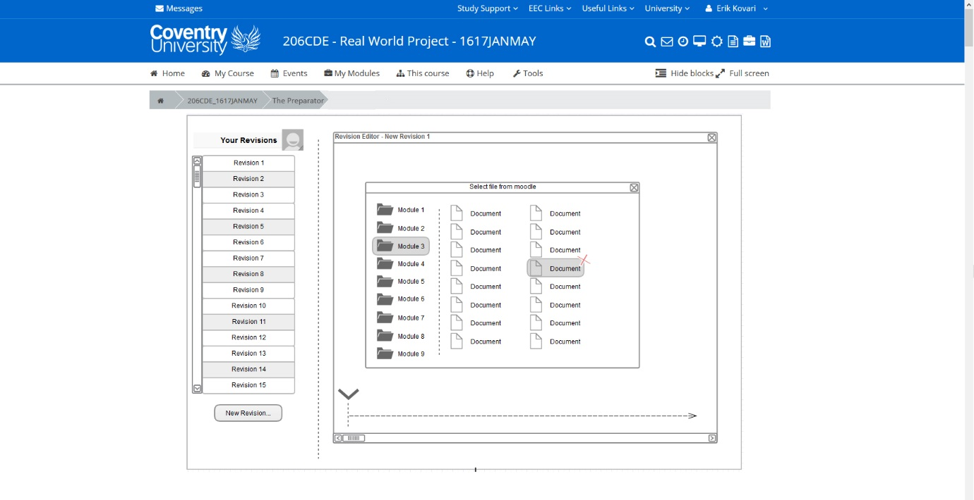

1. Once the document is selected, drag and drop pages relevant to create the revision pdf. Save and finalise to timeline.

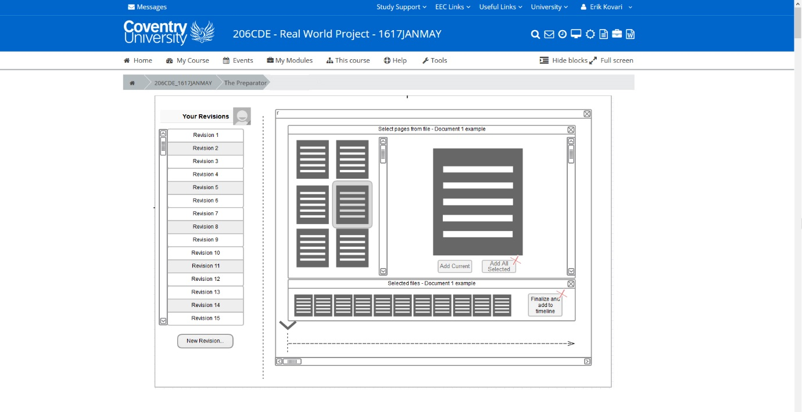

1. The saved information will appear in timeline and it gives you another option to create a new topic or finalise and add to Moodle.

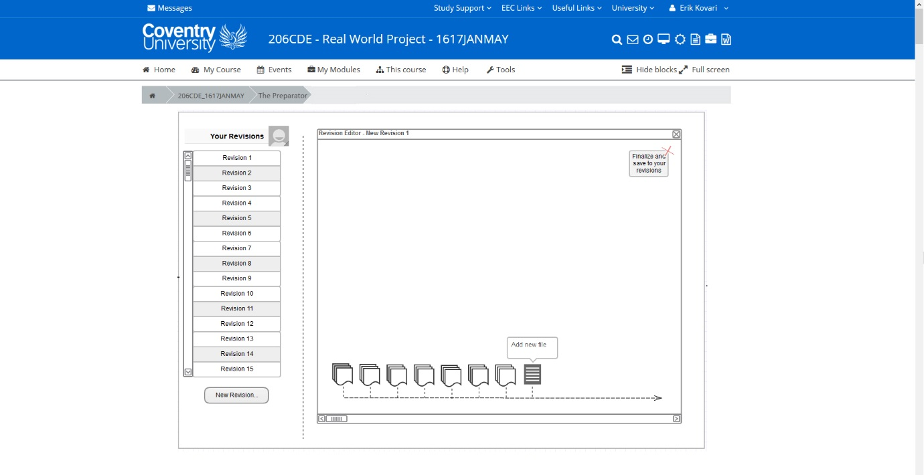

1. After clicking save, you can name your PDF file and save it to be accessible for students on Moodle.

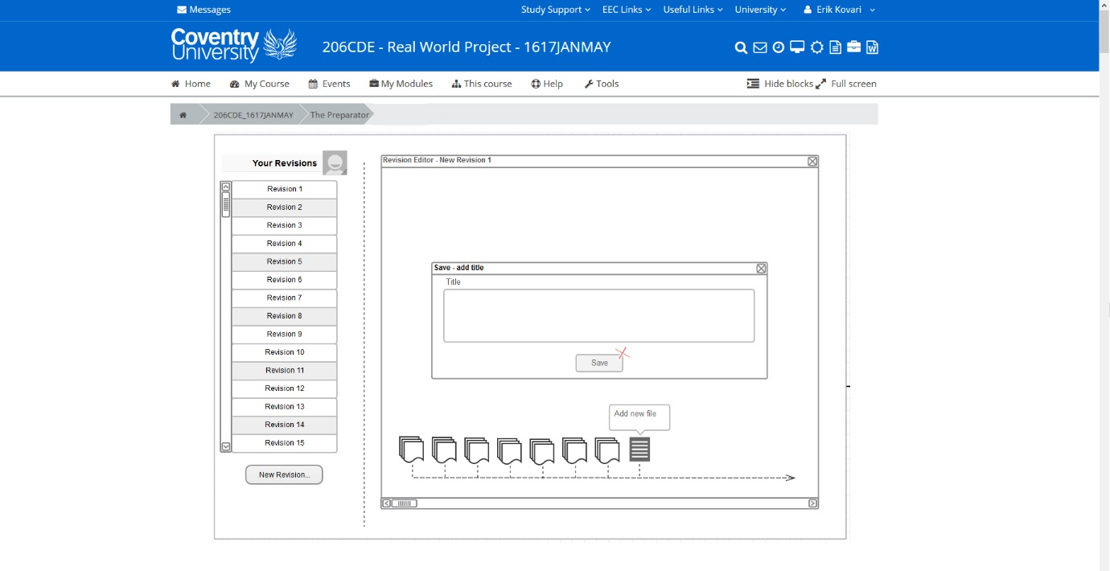

1. This page allows you to publish finalised document to Moodle.

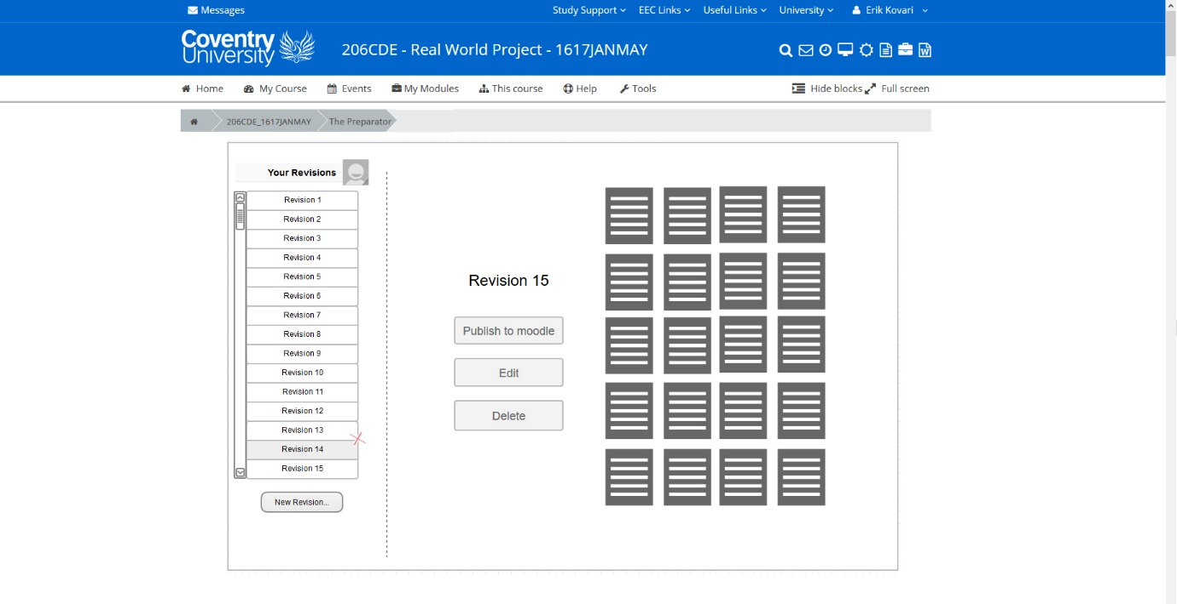

Deleting a file (Lecturer)

1. Log into Moodle with your credentials



1. Select a module



1. Select extension called ‘The Preparator’.



1. The Preparator window opens and Select a ‘Revision number’ to delete.



1. Select a timeline to delete inside selected revision number



1. After selecting a timeline, all files inside that timeline will appear in a new window.



1. Select pages and click ‘Delete’ to remove the files/pages from the timeline and the revision number.

Using the System (Student)

1. Log into Moodle with your credentials



1. Select a module



1. Select extension called ‘The Preparator’.



1. Select a Timeline

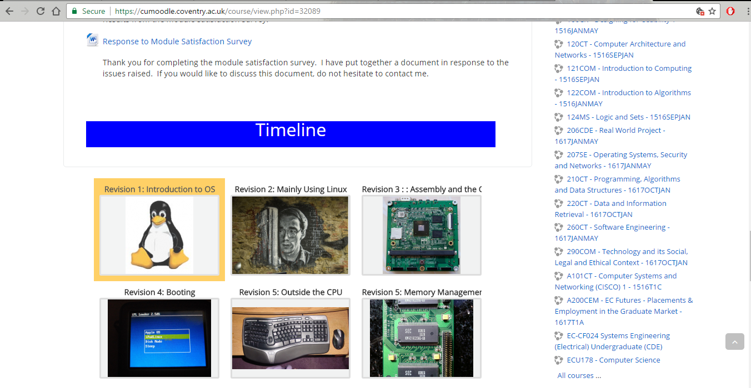

1. Download the pdf file

